Omnifood Project

Goal of The Project: Show what Omnifood does, howit works and in which cities it operates in. Then, make people want to sign up on a subscription plan

Audience: Busy people who don’t have time to cook or don’t like it.

One-Page website containing information provided by Omnifood, with simple navigation

Content: provided by Omniffod in form of a text document and a couple of images

Navigation: Also provided by Omnifood in a text document

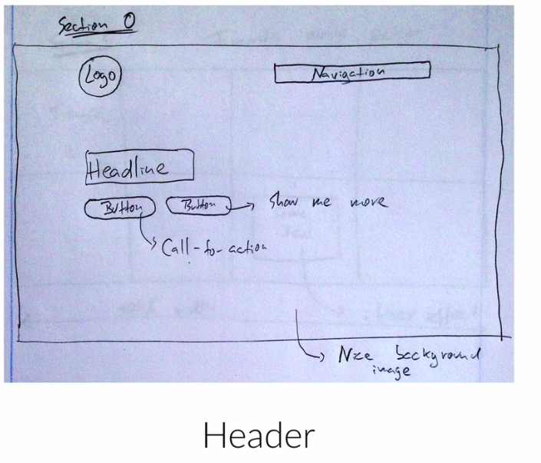

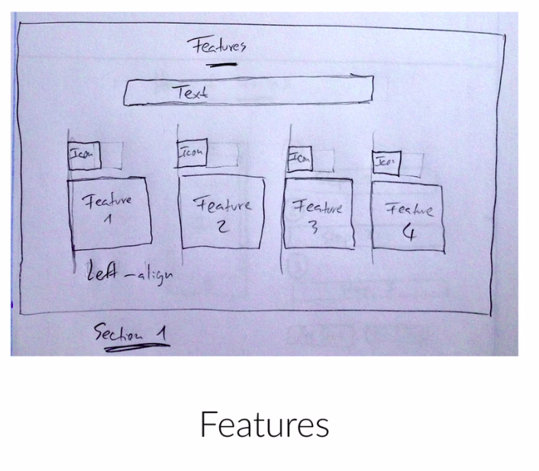

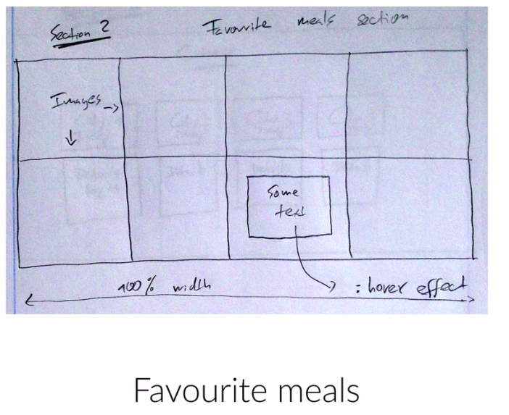

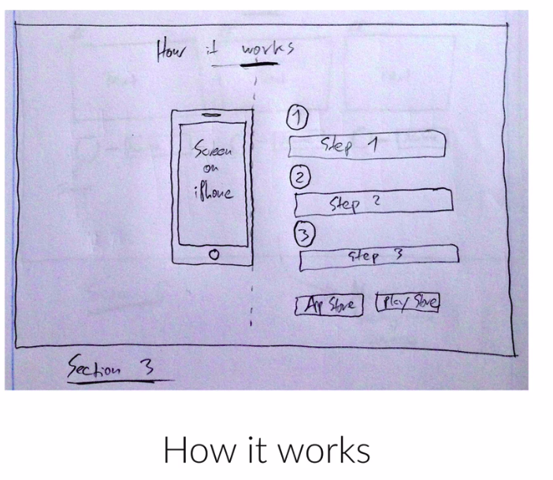

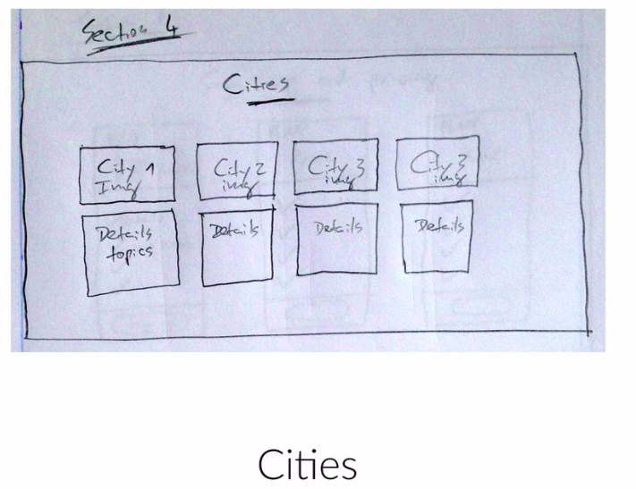

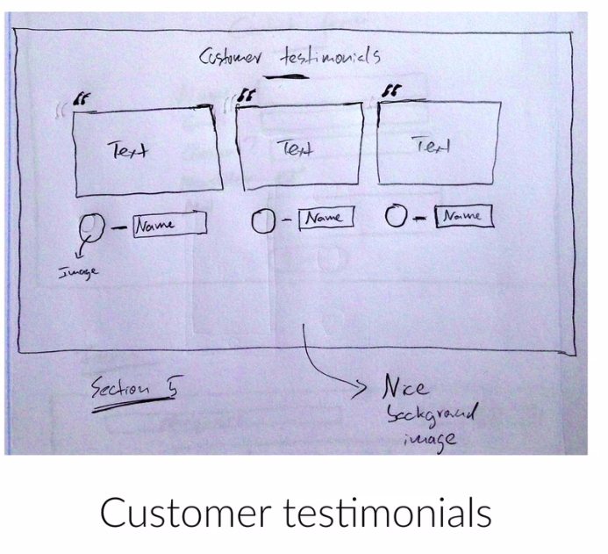

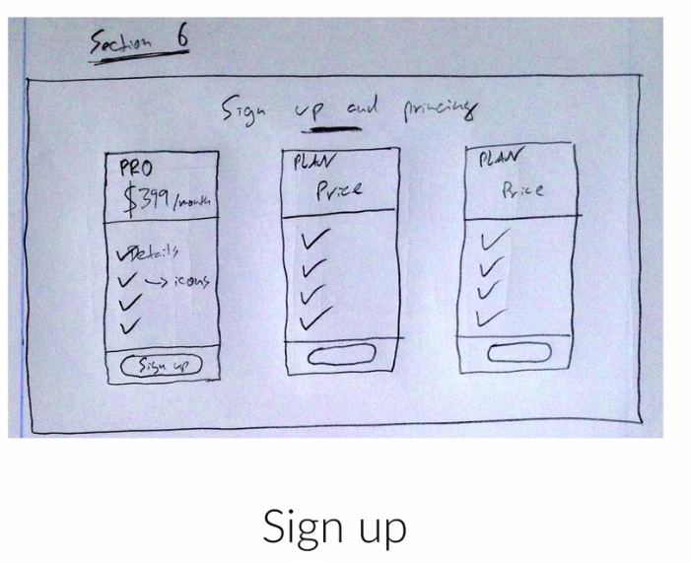
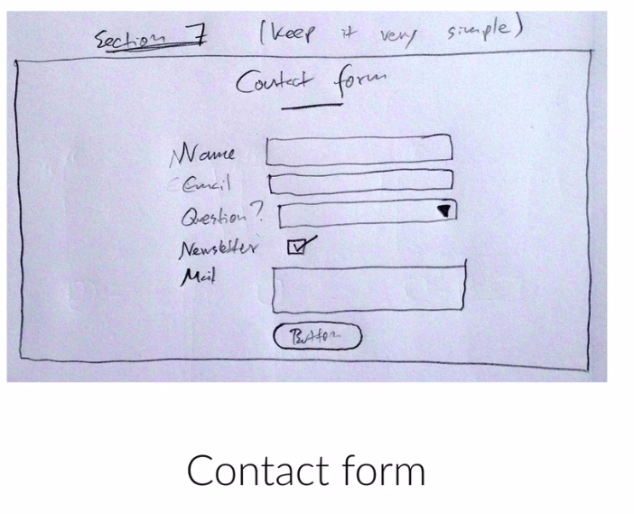

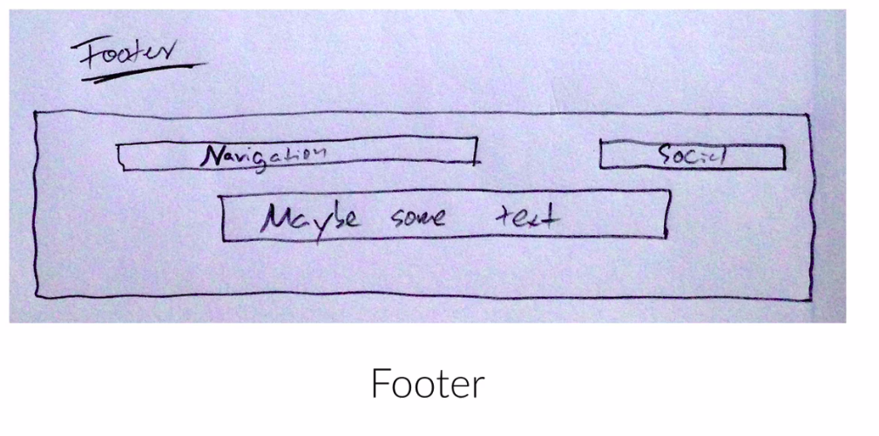
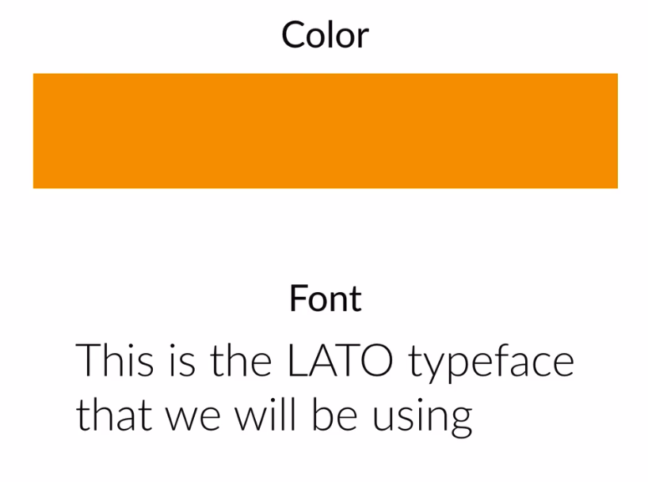

Responsive WebDesign Principles
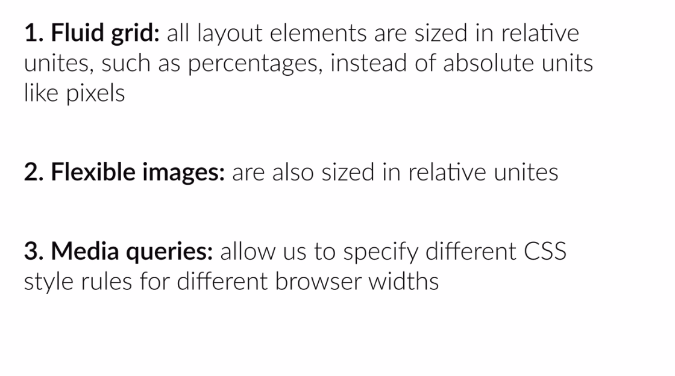
http://www.responsivegridsystem.com/

